|  |
| --- |
| **Software Validation Report**  **(SmartSONO MS-09; SCUS)** |

**Model: SmartSONO MS-09**

**Document No. : Q5-29-028 Rev.4**

This document valid from the date of approval

|  |  |  |  |  |
| --- | --- | --- | --- | --- |
|  | Title | Name | Date | Signature |
| Prepared by | Researcher | H.W. Jung | 2015.05.29 |  |
| Reviewed by | Researcher | J.H Oh | 2015.05.29 |  |
| Approved by | CTO | G.Y. Kim | 2015.05.29 |  |

|  |
| --- |
| META BIOMED Co., Ltd. |

Revision History

|  |  |  |  |  |  |  |
| --- | --- | --- | --- | --- | --- | --- |
| No | Contents | Revision Record (No & Date) | | | | |
| 0 | 1 | 2 | 3 | 4 |
| 1 | Level of Concern | 2014/10/30 | 2015/02/05 | 2015/03/05 |  |  |
| 2 | Software description | 2014/10/30 | 2015/02/05 | 2015/03/05 |  |  |
| 3 | RISK MANAGEMENT | 2014/10/30 | 2015/02/05 | 2015/03/05 | 2015/5/15 | 2015/5/28 |
| 4 | Software Requirements Specification | 2014/10/30 | 2015/02/05 | 2015/03/05 | 2015/5/15 | 2015/5/28 |
| 5 | Architecture Design Chart | 2014/10/30 | 2015/02/05 | 2015/03/05 |  |  |
| 6 | Software Design Specification(SDS) | 2014/10/30 | 2015/02/05 | 2015/03/05 | 2015/5/15 | 2015/5/28 |
| 7 | Traceability | 2014/10/30 | 2015/02/05 | 2015/03/05 | 2015/5/15 | 2015/5/28 |
| 8 | Software development Environment Description | 2014/10/30 | 2015/02/05 | 2015/03/05 | 2015/5/15 | 2015/5/28 |
| 9 | Verification and Validation Documentation | 2014/10/30 | 2015/02/05 | 2015/03/05 |  |  |
| 10 | Revision Level History | 2014/10/30 | 2015/02/05 | 2015/03/05 |  |  |
| 11 | Unsolved Bugs | 2014/10/30 | 2015/02/05 | 2015/03/05 |  |  |
| 12 | Release Version Number | 2014/10/30 | 2015/02/05 | 2015/03/05 |  |  |
| 13 | IEC 62304 Checklist | 2014/10/30 | 2015/02/05 | 2015/03/05 |  |  |
| 14 | Appendix | 2014/10/30 | 2015/02/05 | 2015/03/05 |  |  |

1. **Level of concern : Moderate**

**If the answer to any one question below is Yes, the Level of Concern for the Software Device is likely to be Major.**

1. Does the Software Device qualify as Blood Establishment Computer Software? **No**

2. Is the Software Device intended to be used in combination with a drug or biologic? **No**

3. Is the Software Device an accessory to a medical device that has a Major Level of Concern? **No**

4. Prior to mitigation of hazards, could a failure of the Software Device result in death or serious injury, either to a patient or to a user of the device? Examples of this include the following:

a. Does the Software Device control a life supporting or life sustaining function? **No**

b. Does the Software Device control the delivery of potentially harmful energy that could result in death or serious injury, such as radiation treatment systems, defibrillators, and ablation generators? **No**

c. Does the Software Device control the delivery of treatment or therapy such that an error or malfunction could result in death or serious injury? **No**

d. Does the Software Device provide diagnostic information that directly drives a decision regarding treatment or therapy, such that if misapplied it could result in serious injury or death? **No**

e. Does the Software Device provide vital signs monitoring and alarms for potentially life threatening situations in which medical intervention is necessary? **No**

**If the Software Device is not Major Level of Concern and the answer to any one question below is Yes, the Level of Concern is likely to be Moderate.**

1. Is the Software Device an accessory to a medical device that has a Moderate Level of Concern? **No**

2. Prior to mitigation of hazards, could a failure of the Software Device result in Minor Injury, either to a patient or to a user of the device? **Yes**

3. Could a malfunction of, or a latent design flaw in, the Software Device lead to an erroneous diagnosis or a delay in delivery of appropriate medical care that would likely lead to Minor Injury? **Yes**

**If the answers to all of the questions in Tables 1 and 2 above are No, the Level of Concern is Minor.**

The MANUFACTURER shall assign to each SOFT-WARE SYSTEM a software safety class (A, B, or C) according to the possible effects on the patient, operator, or other people resulting from a HAZARD to which the SOFTWARE SYSTEM can contribute.

The software safety classes shall initially be as-signed based on severity as follows:

|  |  |
| --- | --- |
| Class A | No injury or damage to health is possible |
| Class B | Non-SERIOUS INJURY is possible |
| Class C | Death or SERIOUS INJURY is possible |

Therefore, when you connect the class above-mentioned Major, Moderate and minor, it shows as follows:

|  |  |
| --- | --- |
| Class A | Major |
| Class B | Moderate |
| Class C | Minor |

Classification chart for the acceptance of risks

|  |  |  |  |  |  |
| --- | --- | --- | --- | --- | --- |
|  | **Class A** | **Class B** | **Class C** | | |
| **Negligible(1)** | **Minor(2)** | **Serious(3)** | **Critical(4)** | **Catastrophic(5)** |
| **Frequent(5)** | 3 | 40 |  |  |  |
| **Probable(4)** |  |  |  |  |  |
| **Occasional(3)** |  | 2 |  |  |  |
| **Remote(2)** |  |  |  |  |  |
| **Improbable(1)** |  | 1 |  |  |  |

Risk Level: Severity x Probability

|  |  |
| --- | --- |
|  | Unacceptable risk |
|  | Acceptable risk |

The above Severity Risk Level of system software is always a step below than Serious. Therefore, serious situation does not come so it is Class B. The Class B belongs to Moderate. Therefore, this software is a Moderate and Class B.

1. Software Description
   1. Programming language: ANSI C/C++
   2. Hardware Platform: x86
   3. Operating system: Windows XP
   4. Off-the-shelf: Windows
2. **RISK MANAGEMENT**

The above software system is configured to observe the lesions of a patient through a certain frequency as ultrasonic medical imaging equipment. Therefore, this article was prepared by the Risk management is defined as follows:

For each potential cause of the software item contributing to a hazardous situation documented in the risk management file, the manufacturer shall define and document risk control measures. [Class B, C]

NOTE The RISK CONTROL measures can be implemented in hardware, software, the working environment or user instruction.

RISK CONTROL performed by the following opinion.

If a RISK CONTROL measure is implemented as part of the functions of a SOFTWARE ITEM, the MANU-FACTURER shall:

a) Include the RISK CONTROL measure in the soft-ware requirements;

b) Assign a software safety class to the SOFTWARE ITEM based on the possible effects of the HAZARD that the RISK CONTROL measure is controlling

See the RISK MANAGEMENT document (FMEA table\_SW.xlsx) aforementioned.

1. Software Requirements Specification (SRS)
   1. Hardware Requirements

* + 1. Microprocessors

The main purpose, Ultrasound imaging system (MS-09) is check the lesion. This method is we use the B-scan. Regular Doppler B-scan instruments for this purpose are unwieldy and are not locatable at the bedside. Microprocessor based Ultrasound Display instrument with combined Doppler spectrum view was developed.

This system employs a 6502 microprocessor along with a BASIC interpreter as part of the firmware, so that the calculations particular for Doppler spectrum evaluation could be handled.

* + - 1. Initialization (SRS-M01)

When to power equipment, it will be operated through the first set value. MS-09 is setting the initial state of the HW and SW via the Microprocessor. When the first execution, check whether the operating state of the system is normal. Check whether the problem also occurs in the system by performing the checks Protocol between HW and SW. Through abovementioned processes, it can be checked the problem in the equipment and recognized the system state.

* + - 1. Probe Setting (SRS-M02)

There is a Probe of the sensors that are used in medical devices. It is possible to determine the disease status of the patient through a Probe. Therefore, it should the verification whether or not Probe is recognized to the system. Therefore, it should the verification of whether the probe is disconnected from the system.

If the probe is not connected or incorrectly connected, any measures needed to allow users to check.

Probe is classified as in several types in accordance with the intended use. Thus, each set is needed with respect to the Probe. It reads the ID value through recognized set value of the Probe. The probe is set by the read ID value and it provides information to the user.

* + - 1. System option setting (SRS-M03).

Ultrasound imaging system can be used with different purposes by users. In this regard the system option must set up. The HW configuration should be to match the diagnostic imaging. Through this configuration it is possible to change the options according to the purpose of each user.

* + 1. Memory devices

MS-09 basically confirms the lesion by B-mode. When checking, it usually displays in real-time on the screen. The Memory is required to store the image displayed patient information and images. Typically, more than 60GB Memory is required.

* + - 1. Patient Information (SRS-D01)

It can be stored and can be modified of the patient information. Also it can be recalled the information later and can be modified again. Through patient information user (eg the doctor) can be compared to the diagnosis later.

* + - 1. Save Cline Loop (SRS-D02)

The measured information can be stored as the moving picture. It can call up the stored data and can be deleted again.

* + - 1. Save Image (SRS-D03)

The measured patient information can be stored as the picture. It can call up the stored data and can be deleted again.

* + 1. Sensors

Probe is required to get Data regarding the patient lesion. The Probe will be used in accordance with the observation target. That’s because the frequency and power will be changed according to depth and range of measured area. MS-09 is generally used an array type transducer (Transducer Array). It can be used among Linear, Convex, and Phased Probe. Each usage is as follows.

|  |  |  |  |
| --- | --- | --- | --- |
| Linear | D:\METABIOMED\1_System\Ultrasound_MS09\2.SW\System변경\배포용\Probe Image\7.5MHzL40-1.jpg | Center Frequency:  5~10 MHz  Peripheral vascular  Skeleton-muscular |  |
| Convex | D:\METABIOMED\1_System\Ultrasound_MS09\2.SW\System변경\배포용\Probe Image\3.5MHzR50-1.jpg | Center Frequency: 3.5MHz  Abdomen |  |
| Phased | D:\METABIOMED\1_System\Ultrasound_MS09\2.SW\System변경\배포용\Probe Image\3.5MHzP30-1.jpg | Center Frequency: 3.5MHz  cardiac |  |

It is required to be using the same sensor (Probe) aforementioned.

MS-09 diagnostic ultrasound system can be used the sensor among Linear, Convex, Phased, Sector and Vaginal Probe.

* + - 1. Probe ID Selection (SRS-S01)

MS-09 will have the four ports to connect the Probe. Therefore, when the user selects a different probe during use of the system, it should be changed to. It must be prepared to the choice about this.

* + - 1. Linear Probe Selection (SRS-S02)

As a kind of Probe, it should be selected when connecting to the Linear Probe from the outside.

* + - 1. Convex Probe Selection (SRS-S03)

As a kind of Probe, it should be selected when connecting to the Convex Probe from the outside.

* + - 1. Phased Probe Selection (SRS-S04)

As a kind of Probe, it should be selected when connecting to the Phased Probe from the outside.

* + - 1. Sector Probe Selection (SRS-S05)

As a kind of Probe, it should be selected when connecting to the Sector Probe from the outside.

* + - 1. Vaginal Probe Selection (SRS-S06).

As a kind of Probe, it should be selected when connecting to the Vaginal Probe from the outside.

* + 1. Energy sources

A diagnostic ultrasound system is generating higher than the audible frequency to view the site the user wants to see. To generate the ultrasonic waves, the Probe as the sense should be adjusted from inside the System. In addition, regarding the deepest area, closest area and difference in impedance, it required to be controlled diversely. In this regard, Tx is charge of this process, and this process is referred to as the reflected signal and call it Rx by and large. It must perform a variety of functions internally.

* + - 1. Tx (SRS-E01)

According to the probe options to meet user purpose, Tx cycle and signal processing must be changed to match.

* + - 1. Rx (SRS-E02)

In the process of received signal, determine the gain according to the noise and Amplitude by H/W setting.

* + - 1. Range gate (SRS-E03)

As a function of PW (Pulse Wave), it is used when the acquisition and processing of the information about a particular input field. It is used mainly to obtain information about blood flow.

* + - 1. Focus Delay (SRS-E04)

Each signal must be delayed in order to obtain the information user want to see. It may amplify the value of such signal (phase) through a Delay.

* + - 1. Channel Acq (SRS-E05)

As storing section to obtain information about the Channel of the Probe, it can be used to further improve the image.

* + - 1. Frequency (SRS-E06)

Every probe has its own Frequency to use. By using this Frequency, it can be obtain information of the desired value.

* + 1. Safety features
       1. MI (SRS-S01)

By calculating Mechanical index, it indicates the size of the mechanical impact on the tissue of ultrasound. If it is out of specification, it can increase reliability of equipment by generating a warning.

MI (Mechanical Index) <1.9, will display on the screen. Therefore, if this value is lower than the warning occurred to increase the stability.

,

= maximum value of negative pressure

F = center frequency

If more than 1.9, there is a risk of breaking the cells by generating cavitation. Thus it should not exceed that value in any case.

* + - 1. TI (SRS-S02)

By calculating the Thermal index, it indicates the size of the temperature effects on body tissue of ultrasound. If it is out of specifications, it can increase reliability of the equipment by generating a warning.

* + 1. Communications
       1. Power On/Off (SRS-C01)

The power should be the On / Off by Hardware.

* + - 1. Freeze (SRS-C02)

When imaging, stop the screen when you want to focus a desired image. By the stopped image, the user can be observed and stored image.

* + - 1. Vertical (SRS-C03)

The video screen shows the vertical symmetry. It can be provided to vary the user's point of view, through a variety of digital effect.

* + - 1. Horizontal (SRS-C04)

The video shows the screen horizontally symmetrical. It can be provided to vary the user's point of view, through a variety of digital effect.

* + - 1. Dynamic Range (SRS-C05)

TGC and overall screen brightness can be adjusted through the Dynamic Range internally. In general, the deep section comes to relatively dark due to a weak signal. It is used to complement of it.

* + - 1. Patient Input (SRS-C06)

A variety of patient information can be stored and managed by save. By providing information diagnosed to the user, it aids medical treatment.

* + - 1. Focus# (SRS-C07)

The Focus position can be changed in order to exactly see Lesions that user want to investigate. In addition, two or three parts can be focused to see exactly the number of lesions in one image.

* + - 1. Zoom (SRS-C08)

It can be viewed by expanding lesion that you want to investigate exactly.

* + - 1. Mode Selection (B mode, M mode, CMF mode, PDI mode) (SRS-C09)

It allows the user to view and to select the desired Mode. MS-09 provides a B mode, B / M mode, CMF mode, and PDI mode.

* B mode
  + Measurement should carry on as per the following steps:
    - Record and check the relevant information of the patient. Verify system settings (probe and preset).
    - Scanning the patient.
    - Collect all the data to complete the examination.
    - Press B/Gain on the keyboard to enter into B mode, use menu function to set image parameter in real time state. Carry on various measurements in frozen state.
  + Function Explanation and Adjustment in B Mode
    - Power  
      Range of transmitting power: 0 ~15
    - Frequency  
      Different probes have different Frequency
    - Line Density  
      Scanning density rang: FPS×Hz in the information area will change according to the scanning density.
    - Dyn Range  
      Dyn Range: 0dB~160dB
    - Smooth  
      Processing of image noise
    - Persist  
      Frame averaging
    - THI  
      Enhanced penetration rate: OFF/ON Frequency XXM will show in the information area.
    - Focus#  
      Focus numbers: 0~4. FPS×Hz in the information area will change according to the numbers.
    - Rector  
      Width: 5%~100%. FPS×Hz in the information area will change according to the parameters.
    - iClear  
      This is processing for image signal.
    - Edge Enhance   
      Enhance the edge of the organs.  
      Range: 0~7
    - Gray Map  
      To control the image signal that below a certain gray scale.
    - Horizontal  
      Left/right flips: OFF/ON
    - Vertical  
      Up/down flips: OFF/ON
* B/M mode
  + The examination in B/M mode is generally carried on as follows
    - Obtain a higher quality image in B/M mode. Observe the anatomical structure, and place the interested area in the center of B mode.
    - Move the trackball and place the sampling line in the display area of M mode.
    - Press B/M again to enter into M mode.
    - If necessary, adjust scanning speed, TGC, gain, acoustical power, focus, Dyn Range and so on.
    - Press Freeze can stop the M track.
    - Press Freeze can continue the imaging.
    - Press M can back into B/M mode.
* CMF mode
  + Checks with color bloodstream mode are generally carried out as follows:
    - Choose the interested anatomical area as per the procedure in the B mode.
    - Add color bloodstream after image optimization in B mode.
    - Move the area of interested color bloodstream, close to the center of the image as far as possible.
    - Optimize the parameters of color bloodstream to obtain a higher frame rate and display the appropriate blood flow velocity.
    - Press Freeze and store the image.
    - Record color bloodstream image if necessary.
    - For more information, please carry on as per the process of Doppler mode.
    - The following functional description is based on real time state.
  + Parameter Adjustment in CF Mode
    - Power

Range of transmitting power

* + - Frequency

Probe Frequency

* + - Display mode

Parameters for brightness, color, contrast, and other parameters.

* + - Steer

The angle of sampling box, select Steer.

* + - PRF

Select PRF, “FPS×Hz” and “PRFC×Hz” in information area will change as per the value. Speed range/ pulse repetition frequency (PRF) determines the maximum speed which can be observed. If the speed is too high, the accuracy will decrease. It is needed to decrease PRF in high frequency mode.

* + - Baseline

Select Baseline. It is mainly used to increase the scope of Doppler bloodstream velocity and reduce confusion of spectral direction.

* + - Threshold

It is the critical value of gradation and contrast. It is mainly used to enhance image contrast.

* + - Wall Filter

Select Wall Filter

* + - C Persist

Select C Persist

* + - Ensemble

Select Ensemble. FPS×Hz” in information area is changed according to the value.

* + - C Speed

Select C Speed.

* PDI mode
  + PDI (power Doppler Imaging) mode (B+ C+ D mode) is a kind of color flow imaging technique, which reflects Doppler signal strength instead of signal frequency shift. The ultrasonic system draws color flow based on the reflector numbers of motion regardless of the speed. PDI mode cannot reflect the speed of imaging, so there is no aliasing.
    1. External equipment
       1. DICOM (SRS-X01)

It provide to DICOM for sharing information between users and hospitals.

* + - 1. External Printer (SRS-X02)

It can be connected the outside to print the large sheet of the paper.

* + 1. **Imaging Processing and Motion (H/W)** 
       1. **Demodulator (SRS-PH01)**

In PDI Mode, the demodulator will be used to determine the information on the blood flow.

* + - 1. **Clutter Filter & Hilbert (SRS-PH02)**

The received echo signal via Hardware can be reduced by using Filter and Hilbert.

* + - 1. **ADC (SRS-PH03)**

Analog signal can be read as a signal by converting to the Digital.

* 1. Programming Language Requirements
     1. Program Language
        1. Main UI & sequence (SRS-PP01)

Editor : MS visual studio

Debugger : MS visual studio

Compiler

C compiler : MS visual studio

Assembler : MS visual studio

Linker : MS visual studio

* + - 1. Firmware (SRS-PP02)

Editor : Visual DSP

Compiler

Assembler : Visual DSP

C compile : Visual DSP

Linker : Visual DSP

Editor : FPGA

Compiler

Assembler : Xilinx FPGA

Linker : Xilinx FPGA

* + 1. Programming Tools and Library (SRS-PP03)
       1. Editor: Microsoft Visual 2010
       2. C++ compiler: Microsoft Visual 2010
    2. Program Size (SRS-PP04)

- Main UI & sequence: about 10MB

- Firmware: about 1MB

* 1. Interface Requirements
     1. Printers (SRS-I01)

MS-09 is commonly used for SONY-UP-D898MD. The image can be preserved and provided by printing.

* + 1. Monitors (SRS-I02)

15 inch monitor is used.

* + 1. Keyboard (SRS-I03)

QWERTY key type Keyboard is used. The keyboard is the same as the conventional keyboard and it may be used with no resistance to the user. It also provides an additional option for the user's convenience.

* Annotation
* Application
* Body Mark
* Setting
* 4B
* Flips
* Puncture
* Middle Line
* Close Body Mark
* Probe Selection
* ATGC
  + 1. Mouse (SRS-I04)

Mouse used the Track Ball Type.

Used to select, adjust, and move objects on the screen. For example, it controls the caliper position, CPD/Color box position and size, floating cursor, and more. The arrow keys control much of the same functionality as the trackball.

* + 1. Functions for checking DB size & compaction DB (SRS-I05)

DB is used to check the version management and further information modified of Software.

* + 1. USB (SRS-I06)

It provides a USB ports to connect the external memory and other equipment connection.later.

* Version 2.0 : 2 pcs
  + 1. LAN (SRS-I07)

It provides a communication device for connection to the external environment.

* RJ-45
  + 1. VGA (SRS-I08)

It provides the connector for user to connect an extra monitor as a user convenience.

* + 1. CP (Control Panel, SRS-I09)

System should be changed for user to obtain the desired information. At this time, the service panel is provided for changing easily. Mainly in the panel, the options user want are provided.

* Depth  
  Scanning depth
* Focus  
  Multi- Focus & Adjusting focus position
* Zoom  
  Multi- Focus & Adjusting focus position
* Angle  
  Adjusting scanning area & Move M-Mode Line
* Filter  
  Wall Filter
* BFV  
  Blood velocity
* Patient  
  Access to patient information
* Printer  
  Prints the active image to the printer
* Adjust  
  Adjustment knob for the six keys on the Upside (【Depth】【Focus】【Zoom】【Angle】【Filter】【BFV】)
* Doppler  
  In real time, response to black and white pulse Doppler and pulse Doppler in bloodstream mode
* CFM  
  Press once to enter into bloodstream mode (C mode), gain adjustment
* B/Gain  
  Press once to enter into brightness mode (B mode), gain adjustment
* Probe  
  Probe conversion
* B/B  
  Entering B/B or 4B mode
* B/M  
  Entering B/M mode
* Steer  
  Image rotation
* Change  
  Change the live image on the 2B and 4B Mode
* Update  
  Revision, correction
* Clear  
  Clear
* Esc  
  Equivalent to the right mouse button.
* Set  
  Confirming, equivalent to the left mouse button.
* Distance  
  Distance measurement
* GA  
  Application Area for measurement
* Upper Arrow  
  Upward
* Under Arrow  
  Downward
* on the left of Arrow  
  Leftward/ Decrease
* on the right of Arrow  
  Rightward/ Increase
* Cine Save  
  Saving video
* Cine Loop  
  Cineloop, or press this key after press Freeze to enter into the selection menu.
* Save  
  Saving image
* Report  
  Entering the current patient report.
* Freeze  
  Freezing or unfreezing an image.
  + 1. TGC (SRS-I10)

It is provided for the user to be assigned a gain value with regards to the desired point.

* 1. Software Performance and Functional Requirements
     1. Device limitations due to software (SRS-SP01)

|  |  |  |
| --- | --- | --- |
| Device | Description | Range |
| Display monitor | Display device supporting min.  Resolution 1280\*1024. | -Monitor: 15 inch |
| CPU | MS-09 is used for efficient image processing. | -Support SCUS |
| RAM | Minimum memory size for efficient image reconstruction is required. | -1GB or above |
| Mother board | - PCI slot for plugging SICC card  - RS232 communication port to connect OCB and RGU | -VGA slot: 2 or above |

* + 1. Internal software tests and checks (SRS-SP02)

|  |  |  |
| --- | --- | --- |
| Check items | Description | Valid condition |
| License validity | Check license validity to be used by permitted users only. | - Within the term of validity  - Permitted system |
| DB compatibility | Check DB fields for DB compatibility. | - The presence of field supported |
| Patient information | Check the number of patient records and recommend to back up in case of more than the limitation. | - Less than the fixed value of option |
| Disk space | - Check available memory size of disk frequently and display the warning message continuously if the remaining capacity is not enough. | - Less than 10% for free space |

* + 1. Error and interrupt handling (SRS-SP03)

Software handles no interrupt and internal timer interrupt.

* + 1. Fault detection, tolerance, and recovery characteristics Software detects the status of USB connection, and do re-connect if connection is lost. Software checks the validity of image and discards it if not valid. (SRS-SP04)
    2. Safety requirements (SRS-SP05)

|  |  |
| --- | --- |
| Item | Requirement |
| MI | * Mechanical index can be used as an estimate for the degree a given set of ultrasound parameters will induce. Show range display. |
| TI | * Thermal Index (TI) a metric associated with the tissue heating. Show range display |

* + 1. Timing and memory requirements.
       1. Memory Storage (SRS-MS01)

The remaining space of memory should be checked when storing RF Data and video. When 85% of the total space is used, it will be warning to inform the user of it.

* + - 1. System boot time (SRS-MS02)  
         : 90 second
      2. Probe is connected to the system time (SRS-MS03)  
         : second
      3. Time: a user to select a Probe (SRS-MS04)  
         : second
      4. Time printer output (SRS-MS05)  
         : 5 second

* + 1. Identification of off-the-shelf software, if appropriate: Windows
    2. Imaging Processing and Motion (S/W)
       1. DAS (SRS-PS01)

This is modified task for the RF-Data received to DAS (Delay And Sum) is modified by task according to in Time.

* + - 1. Envelop Detection (SRS-PS02)

The signals are gathered + or -. In this case, the image will have a rough phase model. Therefore, correct this problem by changing the signal -into +.

* + - 1. Log Compression (SRS-PS03)

The deeper has the smaller value relatively. Due to that Log scale becomes smaller, compensate for the gain to match the depth.

* + - 1. Distal Scan Conversion (SRS-PS04)

The number of pixels are different from the number of pixels in the ultrasound monitor. Therefore, DSC is needed to overcome the disadvantages.

* + - 1. Base Line (SRS-PS05)

It is mainly used to increase the scope of Doppler bloodstream velocity and reduce confusion of spectral direction.

* + - 1. BODY MARK (SRS-PS06)

It displays a body mark to indicate the portion of the user’s measurement point. At this time UI can be displayed to identify.

1. **Architecture Design Chart**
   1. **Software Diagram and Description**

The software architecture consists of 5 modules and each module functions independently. Main Module combines it into a software unit.

Scan HW

Scan Process module

Main UI module

Database

Firmware module

Sequence module

* 1. **Main Module**

Main UI module initializes hardware and software components in program initial run time and provides user interface to switch four operation areas. And also it has functions to set system options and display the current time and states of disk.



* 1. **Database Module**

Database manages information, such as patients, scan studies, images and protocol information. The image data is stored in separate image file and is connected by DB information.

🡪 Flow chart



* 1. **Scan process Module**

Scan process module works for scanning by sending several commands related for scan to Ultrasound hardware and makes images by post-processing result data of scan. This module also searches tuning value of hardware by pre-scanning.

🡪 Flow chart



* 1. **scan operation flow (After RF Data Acquisition)**

System software operates by scan procedure so as to correspond on clinical procedure. Switching to scan task area is done automatically after registration of patient. User creates study to prepare scan plan, and set scan parameter and scan plane to the study. After preparation of scan plan is completed, it is scanned by load/start scan command. To resume scanning additionally, creation of study, preparation of scan plan and load/start scan are repeated. When all of scan is finished, it is switched to patient registration task area by selecting end scan.

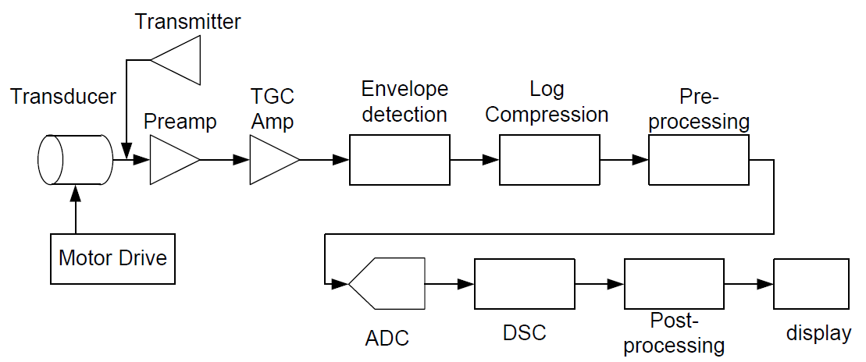



* 1. **Pre-amp operation flow**

By option all procedure of pre-scan or a part of pre- can be executed. In the general scan procedure, pre-scan is executed at first when pre-scan is ON and main-scan is executed using the searched values there again. At pre-scan step, received data week RF. Therefore, this progress is important.



* 1. **Firmware Module**

Firmware module is executed in DSP HW and works for RF signals and acquiring Ultrasound signals from patient

Firmware is executed by the following procedure.

1. After firmware data is downloaded from CCS to each DSP and DSP is booted, check if booting states is normal.
2. CCS downloads parameters for scan at DSP.
3. If CCS commands SCANREADY, firmware creates data structures for scan and prepares the scan start.
4. If CCS commands STARTSCAN, firmware starts scan by pre-set procedure by each DSP respectively.
   * 1. **Tx flow (PW, Pulse Wave)**



* + 1. **Tx flow (CW, Continue Wave)**



* + 1. **Rx**



1. Software Design Specification(SDS)

|  |  |  |  |  |
| --- | --- | --- | --- | --- |
| Clause | Function | Design Spec | Class | Remark |
| Microprocessor | Initialization | -Create following objects :  HW control / Scan UI /Image Viewer / DB manager | CMainSystem | SDS-M01 |
| -Connect to scan process  (Normal control channel/ real time channel).  -Send Initialization message to scan process  -Check DB status ( size, amount of records, any errors ) | CMRHwCtrl  CAIMsgManager  CAIMsgManagerRT  CPatientDatabase | SDS-M02 |
| -Check Ultrasound HW & display error message.  -Reset Ultrasound HW.( RF Amp ) | CMRHwCtrl | SDS-M03 |
| Probe Setting | First. Probe setting | Probe\_s() | SDS-M04 |
| System option setting | -Supported categories for system options: Scan/Pre-scan/Image processing/DB/System info.  -Save setup information to local file | CSystemOptionsDlg | SDS-M05 |
| Memory device | Patient Information | -Display patient call message  - Blink the message so that it can be noticeable easily | CMainSystem | SDS-D01 |
| Save Cline Loop | -Support flexible format to Include reconstructed image / DB information / raw data  (See below. Database Module) | ::SaveDBDataToFile  ::WriteDataToMIFFile | SDS-D02 |
| Save Image | -Independent Image reconstruction  -Support extensible post processing interface | CScanSeries | SDS-D03 |
| -Import or export images in the DICOM/bitmap format. | CImageViewerCtrl | SDS-D04 |
| Sensors | Probe ID Selection | First. Probe Selection Mode | Mode\_s() | SDS-S01 |
| Probe Selection | Linear Probe Selection | Mode\_Ls()  Probe\_m()  Cconf\_L()  Ddef\_L() | SDS-S02 |
| Convex Probe Selection | Mode\_Ls()  Probe\_m()  Cconf\_C()  Ddef\_C() | SDS-S03 |
| Phased Probe Selection | Mode\_Ls()  Probe\_m()  Cconf\_P()  Ddef\_P() | SDS-S04 |
| Sector Probe Selection | Mode\_Ls  Probe\_m  Cconf\_S  Ddef\_S | SDS-S05 |
| Vaginal Probe Selection | Mode\_Ls  Probe\_m  Cconf\_V  Ddef\_V | SDS-S06 |
| Energy sources | Tx | Synthesize real and imaginary signals | Pulse | SDS-E01 |
| Control phase of RF waveform | CalculateOffsetPhase() | SDS-E02 |
| Output the gating signal which controls the On/Off of RF amplifier | Pulse() | SDS-E03 |
| Control the modulator | ChangeTuningFrequency()  ChangeInterploationFrequency()  ChangeOutputScale() | SDS- E04 |
| Rx | Generate ADC waveform | Pulse() | SDS- E05 |
| Process ADC interrupt | WaitForADCIRQ() | SDS- E06 |
| Control the demodulator | InitDownConverter() | SDS- E07 |
| Control the FIFO | Pulse\_F() | SDS- E08 |
| Process multi-channel input | Pulse() | SDS- E09 |
| Process mater clock | IRQ() | SDS- E10 |
| Range gate | Confirm the option (HW) | Crg\_hw() | SDS- E11 |
| Confirm the option (SW) | Crg\_sw() | SDS- E12 |
| Control the gate | Cgt\_c() | SDS- E13 |
| Control the PRI | Cgt\_PRI() | SDS- E14 |
| Focus Delay | Focus delay for Rx | Fd\_Rx() | SDS- E15 |
| Focus delay for Tx | Fd\_Tx() | SDS- E16 |
| Focus delay for RF Data | Fd\_RF() | SDS- E17 |
| Channel Acq | -Create /Delete/Copy series while scanning  -Reserve series for next scan | CTaskScanDlg  CTaskScanSeriesDlg  CScanSeries | SDS- E18 |
| -Create/delete/ modify parameters  -Import/export parameters in the text format  -Check parameter limit & display error message. | CPara  CSlab  CTaskScanPlanDlg  CTaskScanPlanParaDlg  CTaskScanPlanSlabDlg | SDS- E19 |
| -Support 2 or above localizer planes.  -Function for slice arrangement / copy / paste  -Using DICOM coordinate | CLocalizerWnd | SDS- E20 |
| -Copy/save/remove/modification protocol information  -Import/export protocol parameters. | CProtoDBBrowserDlg | SDS- E21 |
| -Scan load / start / stop  -Setting to the center frequency  -Automatic secondary backup in case of ending scan. | CTaskScanDlg | SDS- E22 |
| Frequency | Control the center frequency | ChangeTuningFrequency() | SDS- E23 |
| Safety features | MI | Calculation MI | Calc\_MI() | SDS-S01 |
| TI | Calculation TI | Calc\_TI() | SDS-S02 |
| Communications | Power On/Off | System check to the Power status. If User want Power off, It can Power off. | Find\_P() | SDS-C01 |
| Freeze | If User check to the Image at pause, It can pause it. | Freez\_c() | SDS-C02 |
| Vertical | If User want to change the image position, It can change position. (Vertical) | Cg\_Ver() | SDS-C03 |
| Horizontal | If User want to change the image position, It can change position. (Horizontal) | Cg\_Hor() | SDS-C04 |
| Dynamic Range | Signal compensate to TGC, DR and TOF | Dy\_TGC()  Dy\_DR() | SDS-C05 |
| Patient Input | -Create New patient  -Import existing patient/study information from local DB / Work list server  -Check mandatory information | CPatientStudyRegDlg | SDS-C06 |
| Focus# | - Check to the Focus Position  - If User want Focus number, It have a 3 focus. | Time\_Focus()  Delay\_Focus() | SDS-C07 |
| Zoom | Zoom motion | Zoom() | SDS-C08 |
| Mode Selection (B mode, M mode, CMF mode, PDI mode) | To the Mode selection for your preferences. | Select\_M()  Select\_B()  Select\_CMF()  Select\_PDI() | SDS-C09 |
| External equipment | DICOM | As External option, It can connect to the DICOM. | Co\_D() | SDS-X01 |
| External Printer | As External option, It can connect others printer | Ext\_P() | SDS-X02 |
| Imaging Processing and Motion (H/W) | Demodulator | Demodulation is the act of extracting the original information-bearing signal from a modulated carrier wave. | DeM() | SDS-PH01 |
| Clutter Filter & Hilbert | Data acquired with a clutter rejection (blood wall, organ…) filter is applied to remove high amplitude, low frequency clutter echoes from the Doppler signal, and prior to spectral estimation of blood velocities. | Calc\_Filter()  Calc\_Hil() | SDS-PH02 |
| ADC | Analogue Digital Conversion | ADC() | SDS-PH03 |

|  |  |  |  |  |
| --- | --- | --- | --- | --- |
| Clause | Function | Design Spec | Class | Remark |
| Interface Requirements | Printers | -Display patient call message  - Blink the message so that it can be noticeable easily | CMainSystem | SDS-I01 |
| Monitors | - It passes through the PC board. | Th\_mT()  Con\_mT()  Con\_mT() | SDS-I02 |
| Keyboard | It passes which key was inputted to the PC board. | Ck\_kB()  In\_kB()  Con\_kB() | SDS-I03 |
| Mouse | It passes which mouse was inputted to the PC board. | Ck\_M()  In\_M()  Con\_M() | SDS-I04 |
| Functions for checking DB size & compaction DB | Software Version Up Checking | Ver\_chec() | SDS-I05 |
| USB | It passes which usb was inputted to the PC board. | Ck\_USB()  In\_USB()  Con\_USB() | SDS-I06 |
| LAN | Used to connect with the outside | Cnt\_Lan  Rc\_Lan  Tl\_Lan | SDS-I07 |
| VGA | To use a dual-monitor | VGA\_C  CGA\_T | SDS-I08 |
| CP | Provided for User's convenience | OPC\_CP  Con\_CP  Tran\_CP | SDS-I09 |
| TGC | TGC: Check to the Gain | TGC\_G  TGC\_T | SDS-I10 |

|  |  |  |  |  |
| --- | --- | --- | --- | --- |
| Clause | Function | Design Spec | Class | Remark |
| Timing and memory requirements | Memory Storage | Save to the information.  (Patient, Image, Cine etc…) | STime\_F()  SCon\_F()  Timefor() | SDS-MS01 |
| System boot time | System boot time | Boot\_S  Con\_S | SDS-MS02 |
| Probe recognition time | Probe is connected to the system time | Probe\_S  Con\_P | SDS-MS03 |
| Probe selection time | Time: a user to select a Probe | PS\_S  Con\_PS | SDS-MS04 |
| Print Output Time | Time printer output | Pr\_S  Con\_Pr | SDS-MS05 |

|  |  |  |  |  |
| --- | --- | --- | --- | --- |
| Clause | Function | Design Spec | Class | Remark |
| Imaging Processing and Motion (S/W) | DAS | Delay And Sum : RF Data rearrangement | DAS\_f() | SDS-PS01 |
| Envelop Detection | After DAS, Envelop Detection Operate  (ABS -> Low Pass Filter) | Envelop() | SDS-PS02 |
| Log Compression | The core transform supports streamed compression. It is extended with an adaptation of our word replacement transform for additional improvement of compression ratio. The transform algorithm has low computational requirements. | Log() | SDS-PS03 |
| Distal Scan Conversion | Digital Scan Conversion | DSC() | SDS-PS04 |
| Base Line | It is mainly used to increase the scope of Doppler bloodstream velocity and reduce confusion of spectral direction | BL\_Op()  Con\_Op() | SDS-PS05 |
| Body Mark | It represents an identification tag on the screen. | Bd\_M | SDS-PS06 |

* 1. **TGC**

Attenuation [ = Biological attenuation [ Depth [ Frequency [

* 1. **Envelop Detection**

|  |
| --- |
| B\_env = zeros(data\_total,N\_sc);  for i=1:N\_sc  tmp = Result\_Suming\_Delay(:,i);  tmp1 = abs(hilbert(tmp));  B\_env(:,i) = tmp1;  end |

* 1. **Dynamic Range**

|  |
| --- |
| for a=1:data\_total  for b=1:N\_sc  if (new\_env(a,b) < 10^(-dB/20))  new\_env(a,b) = 0;  else  new\_env(a,b) = 255\*((20/dB)\*log10(new\_env(a,b))+1);  end  end  end |

* 1. **Digital Scan Conversion**

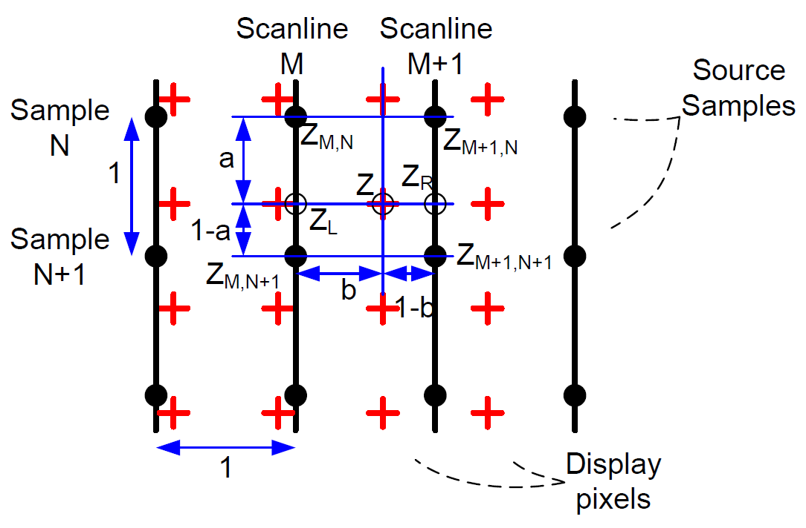

Sample: N

Scanline: M

Source: (N,M), (N+1,M)…….

|  |
| --- |
| for i=1:img\_x  ix = i\*dx;  for j=1:img\_z  iz = j\*dz;    z = iz/pixel\_d;  x = ix/sc\_d;    z\_L = floor(z);  z\_H = z\_L+1;  x\_L = floor(x);  x\_H = x\_L+1;    z\_err = z-z\_L;  x\_err = x-x\_L;    if((z\_L>0) && (z\_H <= data\_total) && (x\_L > 0) &&(x\_H <= N\_sc))  Zon = new\_env(z\_L,x\_L);  Zon1 = new\_env(z\_H,x\_L);  Zin = new\_env(z\_L,x\_H);  Zin1 = new\_env(z\_H,x\_H);    Zri = Zin\*(1-z\_err) + Zin1\*z\_err;  Zro = Zon\*(1-z\_err) + Zon1\*z\_err;  Z = Zro\*(1-x\_err) + Zri\*x\_err;    B\_img(j,i) = Z;  end  end  end |

* 1. **Demodulation**

|  |
| --- |
| CW Oscillator: s\_0 (t)=cos(2πf\_0 t)  Doppler Shift Frequency: s\_1 (t)=Acos(2π(f\_0+f\_d )t+∅)  Out Product: s\_2 (t)=A/2 cos(2πf\_d t-∅)+A/2 cos(2π(2f\_0+f\_d )t+∅)  After HPF: s\_3=A/2 cos(2πf\_d t-∅)  s\_3 is Demodulation |

* 1. **Excitation signal**



The ultrasonic signal that is generated in transmission.

* 1. **Tx**

**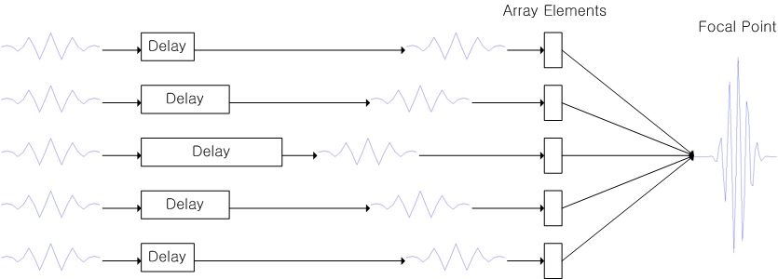**

Signal processing process for a transmission

* 1. **Rx**

**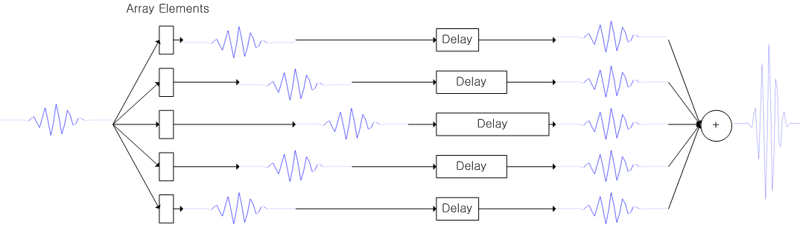**

Signal processing on reception

* 1. **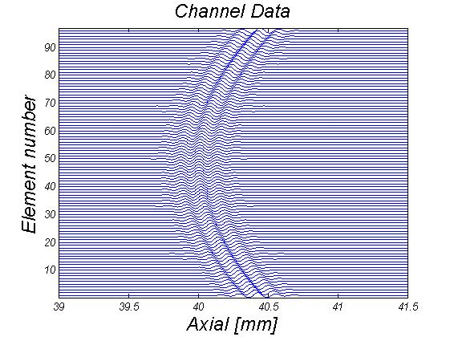Delay Calc**

**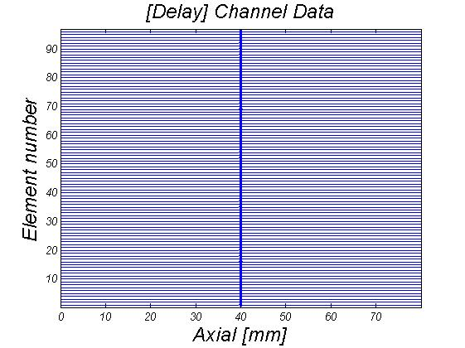**

* 1. **Adsf**

**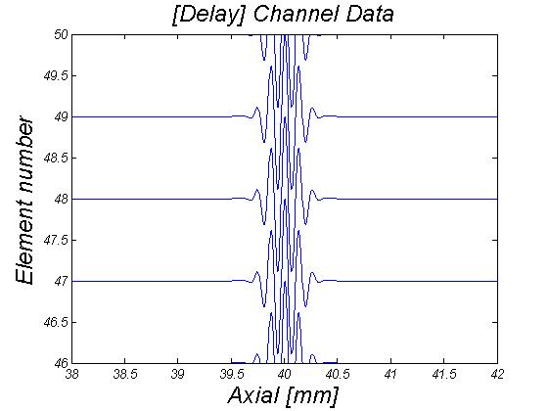**

Signal processing on delay

1. **Traceability**

|  |  |  |  |
| --- | --- | --- | --- |
| **Potential hazard** | **Design requirements** | **Design specification** | **Test/Objective** |
| HZ-01 | SRS-M01  SRS-PP01  SRS-PP02 | SDS-M01  SDS-M02  SDS-M03 | CR-U01 CR-UH01  CR-UH02 MR-U01 MR-U02 MR-U03 MR-U05 IR-01 |
| HZ-02 | SRS-M02 | SDS-M04 | CR-U03 CR-UH03  MR-U10 MR-F06 |
| HZ-03 | SRS-M03  SRS-SP01  SRS-SP02 | SDS-M05 | CR-U03 CR-UH04  CR-UH05 MR-U11 IR-05 |
| HZ-04 | SRS-D01 | SDS-D01 | CR-U06 CR-U07 MR-U08 |
| HZ-05 | SRS-D02 | SDS-D02 | CR-U02 |
| HZ-06 | SRS-D03 | SDS-D03 | CR-U02 |
| HZ-07 | SRS-S01~S06 | SDS-S01 | CR-U03 |
| HZ-08 | SRS-E01 | SDS-E01  SDS-E02  SDS-E03  SDS-E04 | CR-U08 CR-U09 CR-U10 CR-U11 CR-U12 CR-F01 MR-U13 MR-F01 |
| HZ-09 | SRS-E02 | SDS-E05  SDS-E06  SDS-E07  SDS-E08  SDS-E09  SDS-E10 | CR-U08 CR-U09 CR-U10 CR-U11 CR-U12 CR-F03 MR-F04 |
| HZ-10 | SRS-E03 | SDS- E11  SDS- E12  SDS- E13  SDS- E14 |  |
| HZ-11 | SRS-E04 | SDS- E15  SDS- E16  SDS- E17 |  |
| HZ-12 | SRS-E05 | SDS-E18  SDS-E19  SDS-E20  SDS-E21  SDS-E22 | CR-U16 MR-U07 MR-F05 |
| HZ-13 | SRS-E06 | SDS-E23 | CR-U16 CR-S01 MR-F02 MR-F03 |
| HZ-14 | SRS-S01  SRS-SP03  SRS-SP05 | SDS-S01 | MR-U04 |
| HZ-15 | SRS-S02  SRS-SP03  SRS-SP05 | SDS-S02 | MR-U04 |
| HZ-17 | SRS-C02 | SDS-C02 | CR-U16 |
| HZ-18 | SRS-C03 | SDS-C03 | CR-U05 CR-U10 CR-U13 |
| HZ-19 | SRS-C04 | SDS-C04 | CR-U05 CR-U10 CR-U13 |
| HZ-20 | SRS-C05 | SDS-C05 | CR-F02 MR-S01 |
| HZ-21 | SRS-C06 | SDS-C06 | CR-U06 CR-U07 |
| HZ-22 | SRS-C07 | SDS-C07 | CR-U16 MR-U06 |
| HZ-23 | SRS-C08 | SDS-C08 | CR-U16 |
| HZ-24 | SRS-C09 | SDS-C09 | CR-U09 CR-U16 MR-U14 IR-03 IR-04 |
| HZ-25 | SRS-X01 | SDS-X01 | CR-U17 |
| HZ-26 | SRS-X02 | SDS-X02 | CR-U14 |
| HZ-27 | SRS-PH01 | SDS-PH01 | CR-U14 IR-02 |
| HZ-28 | SRS-PH02 | SDS-PH02 | CR-U14 IR-02 |
| HZ-29 | SRS-PH03 | SDS-PH03 | CR-U14 IR-02 |
| HZ-30 | SRS-I01  SRS-PP03 | SDS-I01 | CR-U06 CR-U07 MR-U09 |
| HZ-31 | SRS-I02 | SDS-I02 | CR-U14 |
| HZ-32 | SRS-I03 | SDS-I03 | CR-U14 |
| HZ-34 | SRS-I05 | SDS-I05 | CR-U04 CR-U18 MR-U15 |
| HZ-35 | SRS-I06  SRS-I04 | SDS-I06  SDS-I04 | CR-U14 |
| HZ-37 | SRS-I07  SRS-C01  SRS-I08 | SDS-I07  SDS-C01  SDS-I08 | MR-U04 |
| HZ-38 | SRS-I09 | SDS-I09 |  |
| HZ-39 | SRS-I10 | SDS-I10 |  |
| HZ-40 | SRS-MS01  SRS-PP04  SRS-SP04 | SDS-MS01 | CR-U04 |
| HZ-41 | SRS-PS01 | SDS-PS01 | CR-U16 |
| HZ-42 | SRS-PS02 | SDS-PS02 | CR-U16 |
| HZ-43 | SRS-PS03 | SDS-PS03 | CR-U16 |
| HZ-44 | SRS-PS04 | SDS-PS04 | CR-U16 MR-U12 |
| HZ-45 | SRS-PS05 | SDS-PS05 |  |
| HZ-46 | SRS-PS06 | SDS-PS06 |  |

1. **Software development Environment Description**
   1. **Development Life Cycle**

To aid the development process, task lists showing specific deliverables, by phase, are used as a form of guidance. Atypical list is

shown in the table below.

|  |  |  |  |  |  |
| --- | --- | --- | --- | --- | --- |
| **Phase**  **Se** →  ↓**Group** | **Definition** | **Design** | **Implementation** | **Qualification** | **Maintenance** |
| System  Architecture | *Requirement*  *Specifications* | *Architecture Specification*  *System Design Specification*  *Design Reviews* |  | Test Support | Support |
| Software |  | *SW Requirements and Spec.*  *Software Design and Spec.*  *Design Reviews* | *Completed Software*  *Build Environment*  *Code Reviews & Inspections*  *Test Requirements Specification*  *Updated Software Design Specs* | Test Support | Support |
| Design  Assurance | Preliminary Schedule  Independent V & V | Source Code Analysis  Problem Analysis  Hazard Analysis  Independent V & V | Additional test cases  Automated tests  Independent V & V | Execution of Tests  V & V Documentation  V & V Report  Internal Audit Report  Product & Test Certification | Support |
| Technical  Publications | Documentation  Support Plan | Documentation Design | Completed user and service  documentation | Documentation reviews | Support |

Items in italics indicate a document or an activity which produces a document.

**Group Responsibilities by Development Phase**

* + 1. **Development Life Cycle Procedure**

Software development process at ABC. Follows a classic waterfall methodology, as illustrated in the following chart

Analysis

Planning

Basic Design

Detailed Design

Implementation, Unit Test

Integration Test

Validation & Verification Test

Monitoring

**Definition**

**Design**

**Implementation**

**Qualification**

**Maintenance**

Quality Assessment and Planning

**Classic " Waterfall" Life Cycle Model**

**Analysis.** The activity consists of establishing requirements for as much as possible before the design phase. The requirements are documented in the software-specific requirements and design notes. When enough of the requirements are gathered and analyzed for this iteration of the prototype, the activities shift into the design phase.

**Planning.** This activity constructs the software development plan. This plan outlines the tasks, responsibilities, resources, and other items pertinent to the specific development project.

**Design.** This activity considers four functional attributes of the software: data structure, software architecture, functionality, and interface characterization. The design is documented in design documents.

**Implementation.** The implementation phase converts the design into a machine readable form. The software source code is created in accordance with SCUS's coding conventions. To verify that the code created is consistent with META BIOMED Co., Ltd.. standards, design reviews/inspections are held.

**Qualification.** The qualification phase verifies that the design and code implemented meet the requirements. Testing ensures that defined input will produce actual results that agree with required results.

**Maintenance.** Once the software enters a released state, the only software changes allowed are to fix identified defects in the code or to support approved enhancements. All identified system software defects are recorded on System Discrepancy Reports(SDR) forms or submitted electronically to the Modification Request(Ultrasound) database.

* + 1. Description of Development Life Cycle

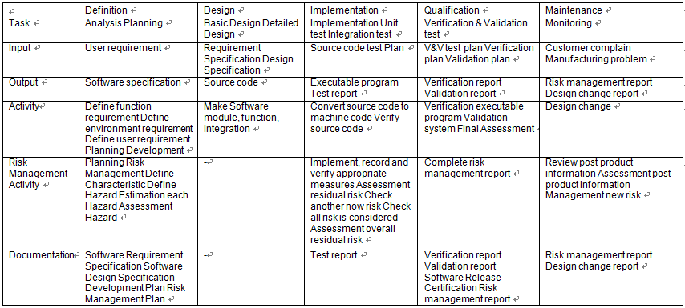

* 1. **Software Maintenance Life Cycle**
     1. **Software Maintenance Life Cycle Procedure**

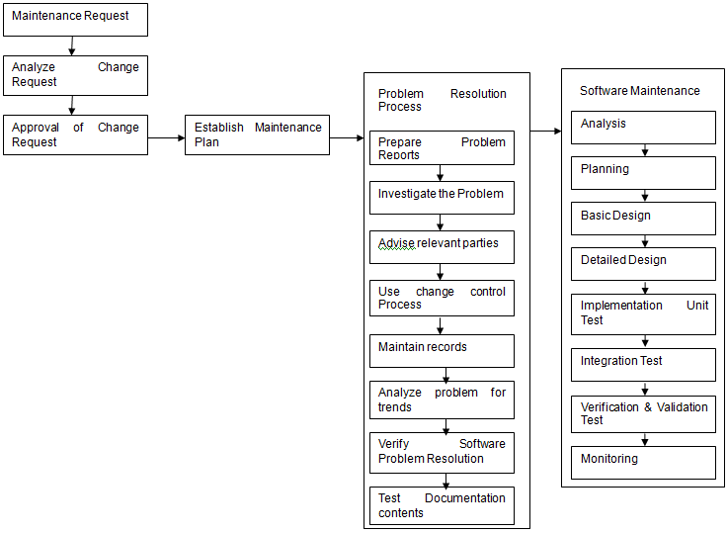

* + 1. **Description of Software Maintenance Life Cycle Procedure**

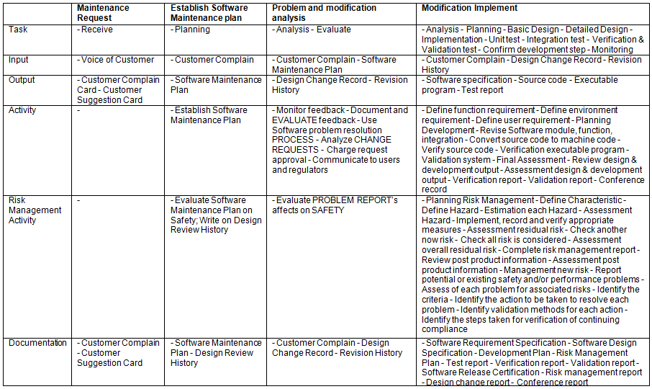

* 1. **Software Configuration Management Life Cycle**
     1. **Software Configuration Management Life Cycle Procedure**

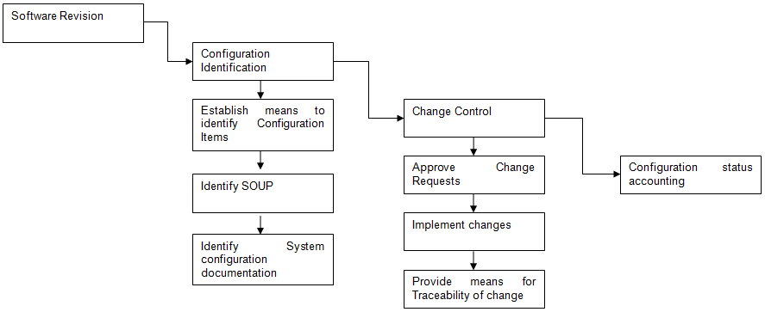

* + 1. **Description of Software Configuration Management**

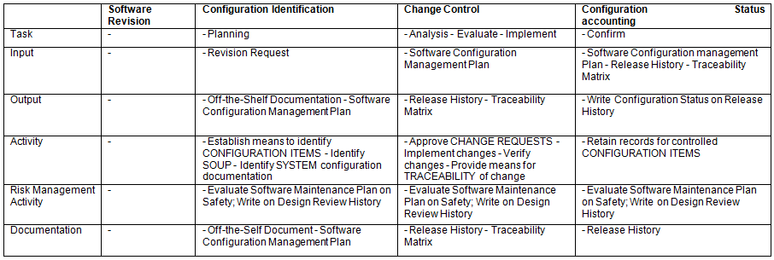

1. **Verification and Validation Documentation**
   1. **Abbreviations and Symbols**

ISO: International Organization for Standardization

SOP: Standard Operating Procedure,

QM: Abbreviation for Quality Manual Document

QR: Abbreviation for Quality Record

QWI: Abbreviation for Quality Work Instruction

SRS: Abbreviation for Software Requirements Specification

SVVP: Abbreviation for Software Verification and Validation Plan.

SVVR: Abbreviation for Software Verification and Validation Report.

* 1. **Definitions**

In addition to an ordinary English-language meaning, each term listed in this section has a specific meaning applicable to the scope of this document.

Some of the terms are also defined in the ISO13485 standard

* Acceptance Testing: Testing to determine if the software correctly implements hardware and software requirements in an operational environment.

Acceptance testing also challenges the adequacy of user documentation.

* Algorithm Analysis: Testing to determine that algorithms have been properly implemented according to the requirement and design specifications. Algorithm Analysis is performed using a variety of techniques including comparisons to measured data and hand computations.
* Black Box Testing: See the definition for “Functional Testing”.
* Clear Box Testing: See the definition for “Structural Testing”.
* Functional Testing: Also known as “Black Box Testing”. Functional Testing consists of executing a variety of functional tests to assess the performance of the product within its integrated system. Functional Testing methods focus on the functional requirements of the software as defined by the SRS, and include but are not limited to performance tests, interface tests, use case based tests, and design maturity tests.

Functional Testing approaches are used in Integration, System, Beta and Acceptance testing.

* Performance Tests: Functional tests intended to validate the System’s performance against prescribed industry standards and other performance requirements as specified in the SRS. Performance Tests are included in integration testing.
* System Testing: The process of testing an integrated hardware and software system in a production environment to verify that the system meets its specified requirements.
* Unit Testing: Testing conducted to verify the implementation of the design for a single element of software and/or hardware, or a collection of software and/or hardware elements. Employs the static and dynamic testing methodologies defined as “Structural Testing”.
* Structural Testing: It replaced to Section 5.1
  1. **Reference**
     1. Regulatory Standards & Guidances

1. FDA Quality System Regulation 21 CFR, Part 820
2. CDRH Guidance : General Principles of Software Validation
   * 1. Industry Standards and Guidances
     2. ISO 13485 : 2003, Quality management System
     3. IEEE Std 1012-1986, Standard for Software Verification and Validation Plans
     4. IEEE Std 829-1983, Standard for Software Test Documentation

4) EN 60601-1-4 [1996] : Programmable electrical medical systems

* + 1. Internal Standards & Guidances

Design & development procedure

* 1. **Roles and Responsibilities**
     1. **Management Members**

Jung Hyun Woo, Researcher of R&D Team

* + 1. **Hazard Analysis Team : Members, Roles and Responsibilities**

Jung Hyun Woo, Researcher of R&D Team

* + 1. **V & V Testing Team : Members, Roles and Responsibilities**

Oh Jae Hong, Senior researcher of R&D Team

* + 1. **Documentation Review : Members, Roles and Responsibilities**

Oh Jae Hong, Senior researcher of R&D Team

* + 1. **Team Members/Qualifications**

General Qualifications/Requirements as described in each individual’s training file.

* 1. **V.V & T Item & Methods**
     1. **Static Analysis**

a. Code Review: performed by S/W engineer. (Appendix 1)

b. Module Test: performed by S/W engineer. (Appendix 2)

c. Integration Test: performed by S/W engineer. (Appendix 3)

* + 1. **Dynamic Analysis**

Refer to Appendix 4 Dynamic Test Plan.

* 1. **Documentation Handling**

Documentation will be handled in accordance with META BIOMED Co., Ltd. standards outlined in QM Document Control.

1. **Revision Level History**

|  |  |  |  |  |
| --- | --- | --- | --- | --- |
| Rev No | Date of Change | Reason of Change | Applicable Date | Remarks |
| 1.0 | 2015/02 | Complementary to the draft | 2015/02 | RL-01 |
| 2.0 | 2015/03 | Compensate for the modified information. | 2015/03 | RL-02 |
| 3.0 | 2015/05 | Additional information | 2015/05 | RL-03 |
| 4.0 | 201/05 | Additional information | 201/05 | RL-04 |
|  |  |  |  |  |
|  |  |  |  |  |
|  |  |  |  |  |

* 1. **RL-01**

Overall, the situation was due to lack of information. So, this documents exchange the information.

* 1. **RL-02**

Modify the content’s table. First time, the required items were incorrect.

[Existing Item]

SRS->SDS->Architecture Design Chart

[Changed Item]

SRS->**Architecture Design Chart**->SDS

* 1. **RL-03**

Additional information Risk Management.

Because of this additional information it has been changed.

(SRS, SDS, Architecture Design Chart, Traceability)

* 1. **RL-04**

Additional information Risk Management.

Because of this additional information it has been changed.

(SRS, SDS, Architecture Design Chart, Traceability)

1. **Unsolved Bugs**

There were no bugs that are subjected to safety and effectiveness of SCUS.

1. **Release Version Number**

Ver. 4.0

1. **IEC 62304 Checklist**

See the TRF document (TRF Document SW Vaildation.docx) aforementioned.

Appendix 1

S/W Verification Report

Status: **Code Review** / Module Review / Integration Review Date : 2015-05-28

|  |  |  |  |  |
| --- | --- | --- | --- | --- |
|  | Software Requirement | Implemented? (Y/N) | Module | Remark |
| CR-U01 | System initialize | Y | Main UI / Scan process | -Create SW components  -Connect to scan process & perform initialization  -Check DB status |
| CR-U02 | Task area switching | Y | Main UI | - Scan / Image view / Database task switching |
| CR-U03 | System option setting | Y | Main UI | -Save categorized system options to local files |
| CR-U04 | Time & disk status display | Y | Main UI | -Refresh time & disk information according to predefined interval |
| CR-U05 | Scan status display | Y | Main UI | - Display status message and progress information |
| CR-U06 | Patient call display | Y | Main UI | - Display patient call message |
| CR-U07 | Patient /study Registration | Y | Scan UI | -Input or import patient/study information  -Check mandatory information |
| CR-U08 | Scan series management | Y | Scan UI | -Create /Delete/Copy series  -Reserve series |
| CR-U09 | Scan parameter management | Y | Scan UI | -Create/delete/ modify parameters  -Import/export parameters  -Check parameter limit & display error message. |
| CR-U010 | Scan plane localization | Y | Scan UI | -Using DICOM coordinate |
| CR-U011 | Scan protocol management | Y | Scan UI | -Create/delete/modify protocol information  -Import/export protocol parameters. |
| CR-U012 | Scan operation | Y | Scan UI / Scan process | -Scan load / start / stop  -Pre-scan functions  -Check & display MI, TI  -Display real time Ultrasound signal |
| CR-U013 | Image reconstruction | Y | Scan UI / Scan process | -Independent Image reconstruction  -Support extensible post processing interface |
| CR-U014 | HW status checking | Y | Scan UI / Scan process | -Check Ultrasound HW & display error message.  -Reset Ultrasound HW |
| CR-U015 | View result images | Y | Image view UI | -Support various layout & view mode ( 1x1 ~ 2x2, custom, Exam/Series/Stack mode )  -Create various graphic ROI |
| CR-U016 | Image processing | Y | Image view UI | -Support basic tools for image processing (width/level, zoom, flip, inverse, rotation, 2D etc.) |
| CR-U017 | Send images to DB | Y | Image view UI | -Independent process. -Support queuing function  -Show status. |
| CR-U018 | DB optimization | Y | Database UI / Database | -DB compaction function |
| CR-UH01 | System initialize Tx | Y | Main UI / Scan process | - Create Frequency  - Create Tx Power  - Connect to scan process & perform initialization  - Check DB status |
| CR-UH02 | System initialize Rx | Y | Main UI / Scan process | - Create Gain Value  - Calculation: Gain, Amplitude |
| CR-UH03 | System initialize Probe | Y | Main UI / Scan process | - Selection Probe ID  - Check the ID |
| CR-UH04 | System initialize Printer | Y | Main UI | - Check the Print ID number |
| CR-UH05 | System initialize Monitor | Y | Main UI | - Compatible the monitor  - Setting the Resolution |
| CR-UH06 | Interface Requirements (USB) | Y | Main UI, USB | - Confirm to the USB connection |
| CR-UH07 | Interface Requirements (LAN) | Y | Main UI, LAN | - Confirm to the LAN connection |
| CR-UH08 | Interface Requirements (VGA) | Y | Main UI, VGA | - Confirm to the VGA connection |
| CR-UH09 | Interface Requirements (CP) | Y | Main UI, CP | - Confirm to the CP connection |
| CR-UH10 | Interface Requirements (TGC) | Y | Main UI, TGC | - Confirm to the TGC connection |
| CR-F01 | RF waveform generation | Y | Tx | * Change the phase of RF waveform * Change the center frequency * Modulate the RF waveform * Output to RF amplifier |
| CR-F02 | Dynamic Range | Y | DR | * Select Dynamic Range |
| CR-F03 | Receiving signals | Y | Rx | * Demodulate received signal * Process multi-channel input * Send received signal to host system |
| CR-S01 | Pulse sequence | Y | TOF | * Calculate and generate   + RF shape and timing sequence   + ADC information   + Other scan parameters |

2-2 Module Review/ Integration Review : (Not applicable)

**Acceptance** : ◆ Pass ◇ Fail

**Summary** : As a result of code review, we positively evaluate the success in communication interface to provide correct operation of Cosmos Main PCB and programming. Therefore, you may advance to the next stage with the proven software code as the basis. As a result of the code review, we hereby certify that the software verification is properly accomplished

Inspected by :

Reviewed by :

**Appendix 2**

**S/W Verification Report**

Status : Code Review / **Module Review** / Integration Review Date : 2015-05-28

|  |  |  |  |  |  |  |
| --- | --- | --- | --- | --- | --- | --- |
|  | Software Specifications | | | | Implemented? (Y/N) | Remark |
|  | Module | Function | | Function related |
| MR-U01 | Main UI | Initialization | | CreateSystemObjects ()  CheckDatabaseFields() | Y | Verify that HW control / Scan UI /Image Viewer / DB manager are created and displayed properly  Verify that database checking perform normally.  If errors exist, appropriate messages show up. |
| MR-U02 |  | Initialization | | InitializeScanModule() | Y | Verify that scan process is connected normally.  If errors exist, appropriate messages show up. |
| MR-U03 |  | Initialization | | InitializeSystem() | Y | Check the system initialization  If errors exist, appropriate messages show up. |
| MR-U04 |  | Task area switching | | OnButton\_\_\_ () | Y | Verify that correspondent task window shows up and other processing windows are hidden. |
| MR-U05 |  | System option setting | | CSystemOptionsDlg ::OnInitDialog()  CSystemOptionsDlg::OnOK() | Y | Verify that options from local files are loaded normally.  Verify that option changes are saved to local files |
| MR-U06 |  | Time & disk status display | | RefreshSystemDateTime()  RefreshDiskInfo() | Y | Verify that time update is done normally  Verify that disk information update is done normally |
| MR-U07 |  | Scan status display | | OnAddStatusMsg()  OnSetCurStep() | Y | Verify that status message is displayed normally.  Verify that scan step progress is displayed normally. |
| MR-U08 |  | Patient call display | | ProcessEvent () | Y | Verify that patient call message is displayed clearly and blink periodically. |
| MR-U09 | Scan UI | Patient /study Registration | | OnBnClickedButtonPatregImportStudy()  OnBnClickedButtonPatregRegister ()  CheckInformationValidity() | Y | Verify that patient/study information is imported normally.  Verify that mandatory information exist.  If errors exist, appropriate messages show up. |
| MR-U10 |  | Scan series management | | OnScanMaintNewScansession()  OnButtonScanDeleteScan()  OnScanMaintCopyScansession()  OnClickScanSessionList()  ProcessReconEnd () | Y | Verify that creation /deletion/ cloning of series is done normally.  Verify that series reservation is done normally and the series run automatically. |
| MR-U11 |  | Scan parameter management | | OnScanParaMaintImportPara()  OnScanParaMaintExportPara()  VerifyScanParameters() | Y | Verify that creation /deletion/ modification of parameter is done normally.  Verify that importing / exporting parameter is done normally.  Check parameter limit & display error message |
| MR-U12 |  | Scan plane localization | | AddNewRenderer()  LayoutRenderer( mode ) | Y | Verify that renderer is created normally.  Verify that renderer's layout is done normally according to layout mode. |
| MR-U13 |  | Scan protocol management | | OnProtomanipulationCopy()  OnProtomanipulationSaveAs()  OnProtomanipulationRemove()  OnProtomanipulationImportprotocols()  OnProtomanipulationExportprotocols() | Y | Verify that copying /saving/deletion/modification of protocol is done normally.  Verify that importing / exporting protocol is done normally. |
| MR-U14 |  | Image processing | | OnLButtonUpCreating (...)  OnDelete\_ROI\_From\_Selected\_Card(...)  OnZoom\_mode(...)  OnPan\_mode(...)  OnMag\_mode(...)  OnWindowWidthLevel\_mode(...)  OnFlip(...)  OnMirror(...)  OnNagative(...)  OnRotate\_Right(...)  OnRotate\_Left(...)  OnRotate(...)  EnhanceImage() | Y | Verify that image processing functions (width/level, zoom, pan, flip, inverse, rotation) re executed normally. |
| MR-U15 |  | DB optimization | | OnCompactDatabase () | Y | DB size is reduced and error condition is cleared if exist.  Verify that DB is compacted normally |
| MR-F01 | Tx | Output the RF and gating signal | | CreateRFShape()  CreatePulseSequence()  Pulse() | Y | Change the input signal’s amplitude and timing, verify an output signal |
| MR-F02 |  | Control the RF signal’s phase | | CalculateOffsetPhase() | Y | Change the input signal’s phase and verify an output signal |
| MR-F03 |  | Control the center frequency | | ChangeTuningFrequency() | Y | Change the input signal’s center frequency and verify an output signal’s spectrum |
| MR-F04 | Rx | Acquire the signal | | Pulse() | Y | Verify the ADC timing  Verify the number of samples  Verify the acquired signal according to the change of the input signal |
| MR-F05 | Channel Acq | Channel Acq | | Ch\_acp() | Y | Channel timing and DAS.  Make to the Scanline. |
| MR-F06 | Probe  Selection | Probe Selection Mode | | Probe\_s()  Mode\_s() | Y | First, Probe select Mode.  (Linear, Convex, Sector, Vaginal, Micro Convex) |
|  |  |  | |  |  |  |
| MR-S01 | | TOF | Ultrasound compensation | Calc\_TOF() | | Y | Time of Flight |

**2. Acceptance** : ◆ Pass ◇ Fail

**3. Summary :** As a result of module review, all the module tests are completed successfully by utilizing communication function evaluated in the code review. You may advance to Integration review phase. As a result of module review, we hereby certify that software verification is properly accomplished.

Inspected by:

Reviewed by:

Appendix 3

S/W Verification Report

Status : Code Review / Module Review / **Integration Review** Date : 2015-05-28

|  |  |  |  |  |  |
| --- | --- | --- | --- | --- | --- |
|  | Software Specifications | | | Implemented? (Y/N) | Remark |
|  | Status | Function | Module |
| IR-001 | Initialization | System Initialization | Main UI  Scan process | Y | Verify that following functions are performed normally.  -SW components are created and initialized.  -Check DB status.  -Connection to scan process is established.  -If the connection is successful, system initialization request is sent to scan process.  -If system initialization is successful, default task area show up and current disk status & time information is displayed. |
| IR-002 | HW checking | HW status checking | Scan UI  Scan process | Y | Verify that following functions are performed normally.  -If errors exist, error message show up and HW reset command is provided to user.  .-If user select HW reset, current scan is stopped. |
| IR-003 | Scanning | Scan planning | Scan UI  Scan process  Pulse sequence  Database UI | Y | Verify that following functions are performed normally.  -Select scan parameter from protocol DB and save it to scan series.  -Set up scan plane and save plane information at scan series.  -Display scan time by load command. if the value of scan parameter and SAR is not adequate, display the message. |
| IR-004 |  | Scan | Scan UI  Scan process  Pulse sequence  Database UI | Y | Verify that following functions are performed normally.  -Start scanning by scan command.  -Display scan step and its progress along scanning.  -Display series status while scanning.  -when the pre-scan option is turned on, optimization process is performed normally.  -when the scan is completed, start reconstruction.  -when the reconstruction is completed, start post processing.  -Add the completed series & image information to database and refresh database UI. |
| IR-005 |  | End Scan | Scan UI  Scan process  Pulse sequence  Database UI | Y | Verify that following functions are performed normally.  -After all scan are completed, back up DB information and images at the secondary DB.  -Initialize scan task area. |

**2. Acceptance** : ◆ Pass ◇ Fail

**3. Summary** : As a result of Integration review, we hereby certify that all the functions that support system specification are proper. Therefore, you may advance to the next phase. As a result of system Integration review, we confirm that software verification is properly accomplished.

Inspected by :

Reviewed by :

**Appendix 4**

**Dynamic Test Protocol**

|  |  |  |  |  |
| --- | --- | --- | --- | --- |
|  | **Item** | | **Procedure** | **Pass/Fail Criteria** |
| DT-F001 | Functional test | Registration of patient | -Registers patients information ( new patient, import patient/study, work list )  -Abnormal input ( empty value, special character ) | -Verify that there is no errors and the information is displayed normally.  -Verify that abnormal input can be detected |
| DT-F002 | Scan | -Scan with various pre-scan option  -Check images created. | -Verify that main scan are performed normally and expected images are saved local DB. |
| DT-F003 | Image Processing | -Check image annotation  -Do filtering test image. | -Verify that image annotation is displayed normally  -Verify that filter works normally. |
| DT-F004 | Exporting images to external devices | -Send images to DICOM server  -Send images to Printer server  -Make DICOM CD | -Verify that DICOM server receive all the images sent  -Verify that Print server receive all the images sent.  -Verify that the DICOM CD can be read internal or external viewing SW |
| DT-F005 | Limit test | Storage capacity | -Change the limit of hard disk free space and check expected result | -Verify that disk space warning show up |
| DT-F006 | Scan parameters | -Input abnormal scan parameter values and check expected result. | -Verify that scan parameter warning show up |
| DT-P001 |  | Image quality | -Perform image quality test according | -Verify following factors are in acceptable range. |

Inspected by :

Reviewed by :

**Appendix 5**

Dynamic Test

|  |  |  |  |
| --- | --- | --- | --- |
| **Item** | | **Procedure** | **Result** |
| Functional test | Registration of patient | -Registers patients information ( new patient, import patient/study, worklist )  -Abnormal input ( empty value, special character ) | Pass  Pass |
| Scan | -Scan with various pre-scan option  -Check images created. | Pass  Pass |
| Image Processing | -Check image annotation  -Do filtering test image. | Pass  Pass |
| Exporting images to external devices | -Send images to DICOM server  -Send images to Printer server | Pass  Pass |
| Limit test | Storage capacity | -Change the limit of hard disk free space and check expected result | Pass |
| Scan parameters | -Input abnormal scan parameter values and check expected result. | Pass |

Inspected by :

Reviewed by :